Ideation Phase

Define the Problem Statements

|  |  |
| --- | --- |
| Date | 15 October 2022 |
| Team ID | PNT2022TMID26908 |
| Project Name | Project – Skills / Job Recommender Application |
| Maximum Marks | 2 Marks |

**Customer Problem Statement Template:**

Create a problem statement to understand your customer's point of view. The Customer Problem Statement template helps you focus on what matters to create experiences people will love.

A well-articulated customer problem statement allows you and your team to find the ideal solution for the challenges your customers face. Throughout the process, you’ll also be able to empathize with your customers, which helps you better understand how they perceive your product or service.

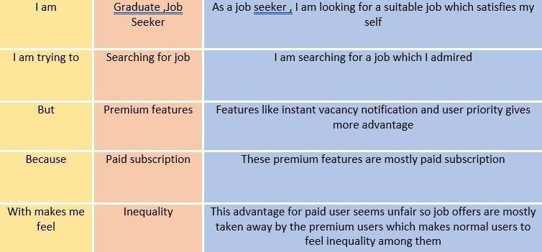

|  |  |  |  |  |  |
| --- | --- | --- | --- | --- | --- |
| **Problem Statement (PS)** | **I am** | **I’m trying to** | **But** | **Because** | **Which makes me feel** |
| PS-1 | Graduate job seeker | Searching for job | Premium features | Paid subscription | Inequality |
| PS-2 | As a job seeker I am looking for a suitable job which satisfies my self | I am searching for a job which I admitted | Features like instant vacancy notification and user priority gives more advantages | These premium features are mostly paid subscription | This advantage for paid user seems unfair so job offers are mostly taken away by the premium users which makes normal users to feel inequality among them |